**The World Population Distribution Report**

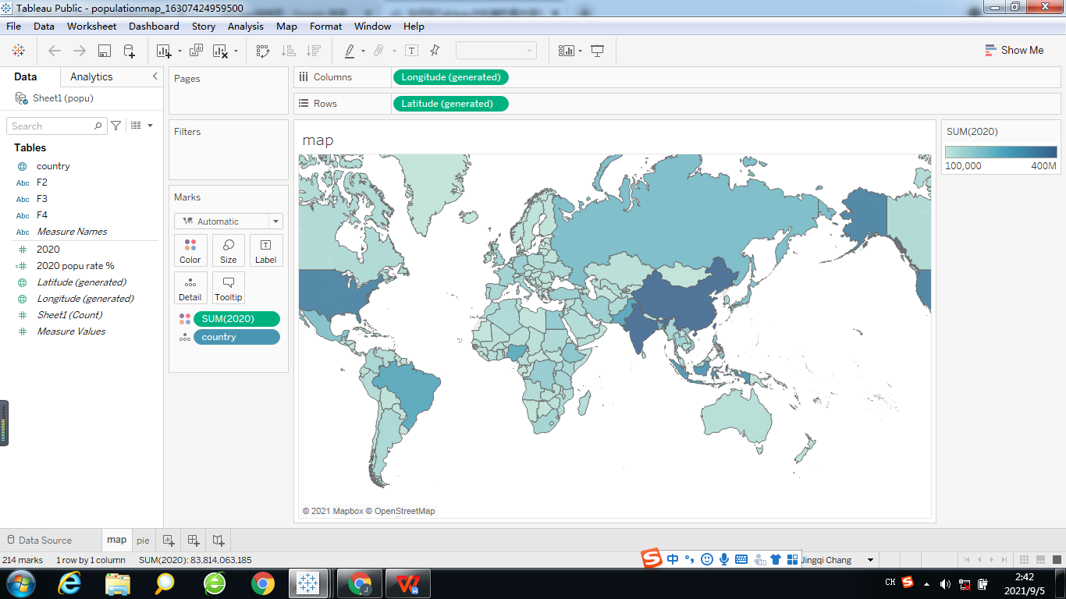

Top 6 most populous countries in the world over the last 60 years (from 1960 to 2020) are China, India, the United States, Indonesia, Brazil and Pakistan respectively. The population of these 6 countries is near half of the world’s population(49.26%).

**Demographic changes in the 6 most populous countries**

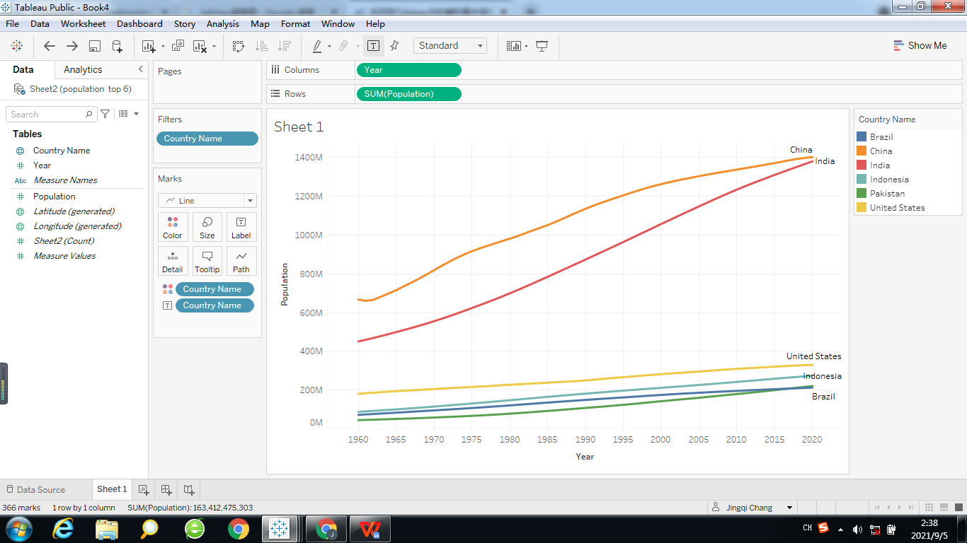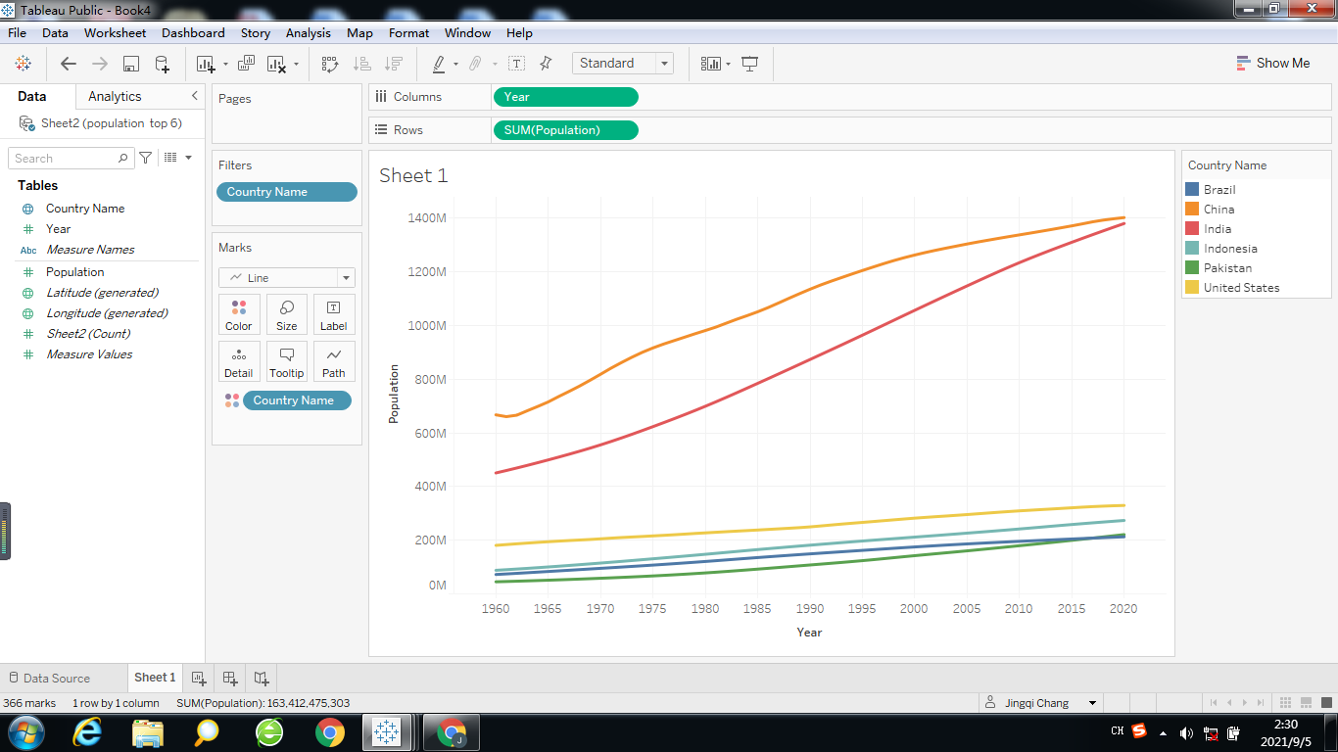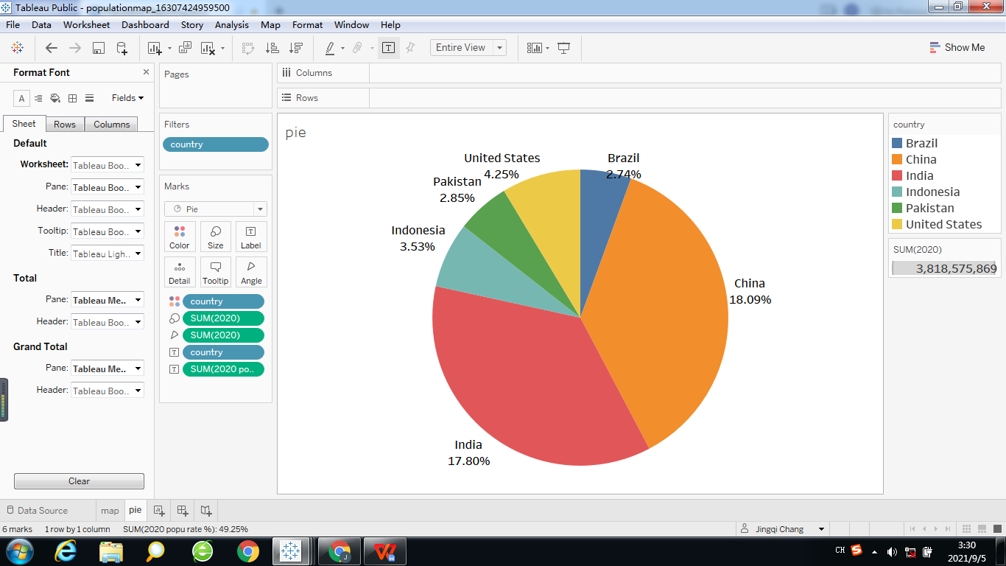

During this 60-year period the population of these 6 countries showed upward trends. The population of China and India account for 1/3 of the world's population.

The population of India had a steady increase to 1.38 billion. The population of China also went up to 1.4 billion, however it rose slowly than the population of India from 19701.

1 China’s family planning policies starting in the early 1970s, it specific birth quotas (three-child policy, two-child policy and the one-child policy). This policy reduced the number of new birth in china, and it still in effect till now.

**Difference of population growth in China and India**

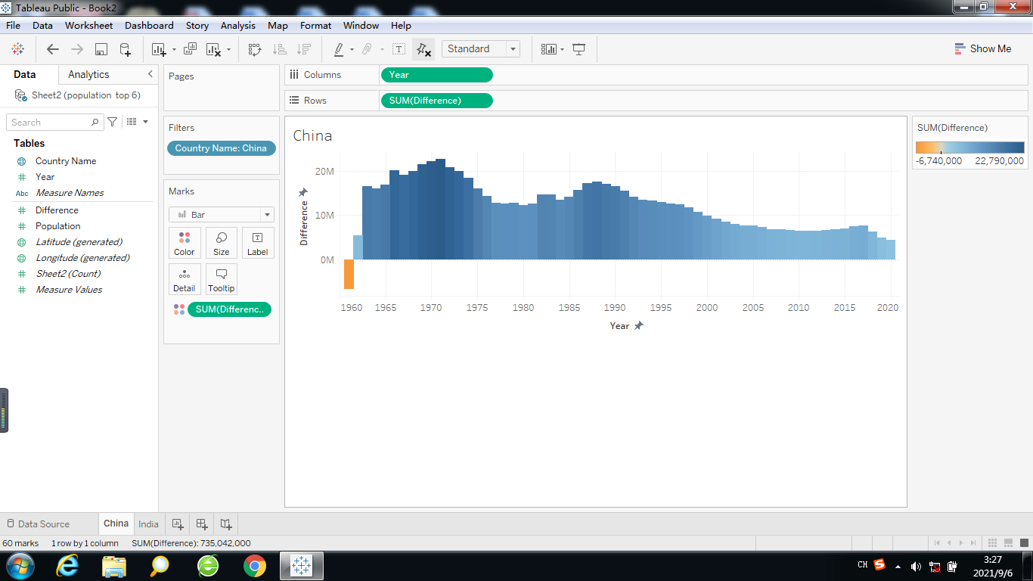

India

China

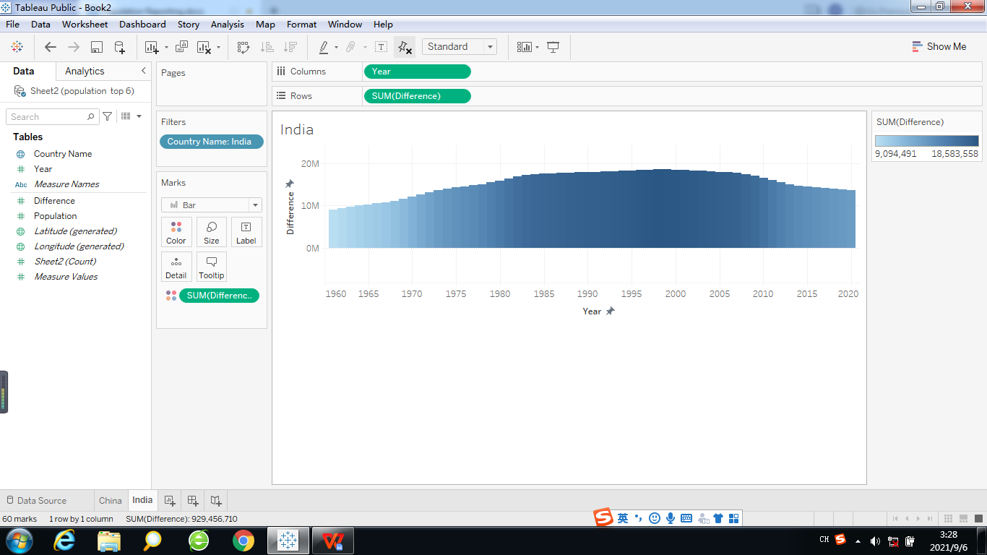

The population difference in China was negative in 19601, and from 1970 due to the fall in the birth rate, China’s population growth rate has dropped. On the other hand, India’s population had a relatively stable growth over the last 60 years. After 1975, China’s annual population growth was not as high as India’s. The population growth rate of India in 2020 was 1%, which was more than three times the population growth rate of China (0.3%).

**Comparison of the number of male and female populations**

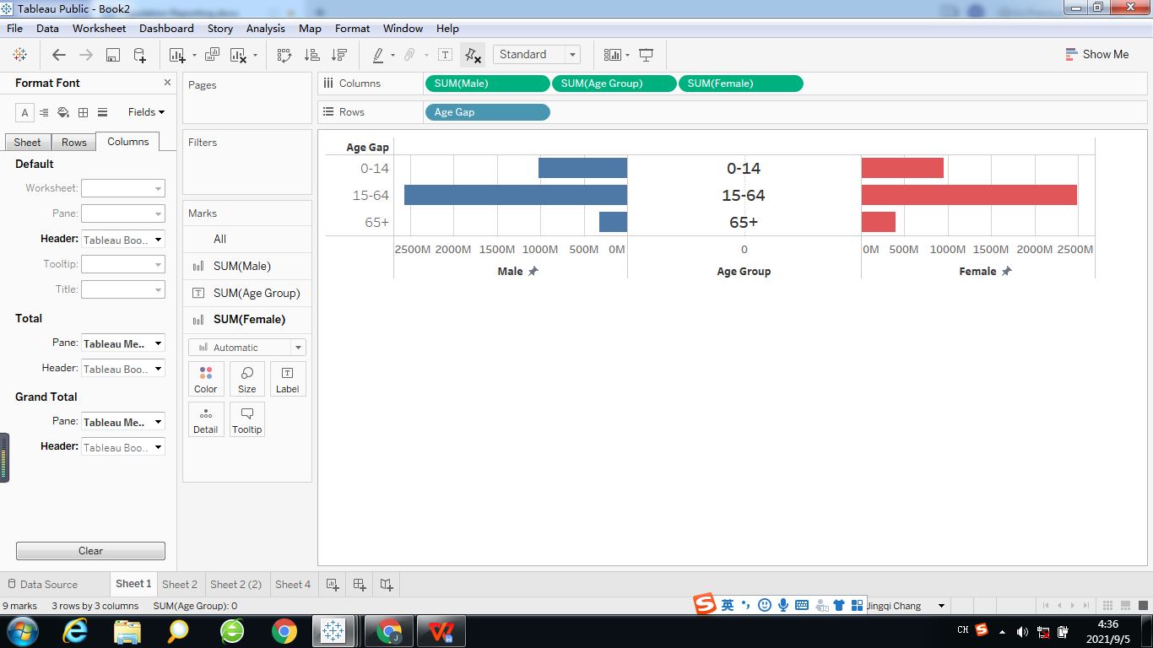

The population of male is a little higher than the population of female in the world between 0 and 64 years old, however the population of female is higher when age over 65. The total sex ratio is 1.03, doesn’t exceed the standard value 1.052.

1 From 1959 to 1961, three consecutive years of natural disasters caused economic ups and downs, affected people’s living standards, a sudden increase in population deaths, and a sharp drop in the birth rate.

2 The natural sex ratio at birth is around 105 boys to 100 girls (ranging from 103 to 107 boys). This is what the World Health Organization (WHO) estimates as the [‘expected’ sex ratio](https://ourworldindata.org/gender-ratio" \l "definitions) at birth.